E-platforms for independent student learning | Resources for independent student learning | E-platforms for creativity
- School Learning Management System (LMS)  Kindly note that practice papers for SEA, NESC and CSEC are now accessible via  https://learn.moe.gov.tt/  - Free Maths Online Classroom  http://www.ilovelessons.com/week-off-work/  - Free Physics Videos  http://www.ilovelessons.com/free-physics-videos/  - Add Maths Classroom  http://www.ilovelessons.com/free-add-maths-videos/  - GT Lessons – CSEC Courses at home tutorials  https://www.gtlessons.com/index  - Demo E-tests  https://www.cxc.org/demo-etests/  - FlowStudy  https://flowstudy.co/registration  - CXC Learning Hub  https://learninghub.cxc.org/ | - Project Jaguar-CSEC Multiple choice Paper- Google drive  https://drive.google.com/drive/u/0/folders/1qyM5EbhPGevSJHqIq5cbIRp70N7dU3-w  - CSEC Past Papers – Google Drive  https://drive.google.com/drive/u/0/folders/12pB5pFf7rPC77MsK6WN__66XiaoqgCwX  - SEA, NCSE,CSEC,CAPE – Google Drive  https://drive.google.com/drive/u/0/folders/1quzhQVN56nQlb_hwMYUrClNJbtyJsLcb?fbclid=IwAR3W1pjrtoamSstIaoR2DAdYDNkdIZstHYj5V6xttqFx7XJtSAEAiUEIdF0  - CSECePastpapers – Google Drive  https://drive.google.com/drive/u/0/folders/0ByPh3PCLEQxATm5DS3JPTDZTcTQ?sort=13&direction=a  - Digital versions of Student Books to support teaching and learning at home  https://docs.google.com/forms/d/e/1FAIpQLScgMKaeR0nJ3jJ3omBL-gMggG-UdBGIu68zSxj6e4K3B11HEw/viewform?region=uk  - Model Answers in Science  file:///C:/Users/MOE_Student/Downloads/Model%20Answers%20in%20Science%20for%20CSEC%20(12)%20(1).pdf | - Mom Creates Periodic Table Battleship Game To Teach Her Kids Chemistry  https://teachbesideme.com/periodic-table-battleship/  - Breakthrough Junior Challenge  https://breakthroughjuniorchallenge.org/?utm_email_kaid=kaid_806410814262948886089155&utm_source=Sailthru&utm_medium=email&utm_campaign=041320-%20breakthrough%20challenge%20Teacher%20Global%20launch&utm_content=C&utm_term=All%20Teachers

Resources for managing physical, emotional, psychological and spiritual help | Resources for entertainment
- 17 Totally Normal Things to Feel Right Now, According to Therapists  https://www.self.com/story/pandemic-therapy-trends?fbclid=IwAR2tOPYrGwWqs0ky-7eopFnHNQZ_PRySEsRWgzVcxohkxkorExZvyQGdubo  - UNICEF: Support Our Work For Children Affected by coronavirus  https://www.unicef.org.uk/  - Coronavirus  A book for children by Elizabeth Jenner, Kate Wilson & Nia Roberts  file:///C:/Users/MOE_Student/Downloads/Coronavirus_ABookForChildren.pdf  9 ways to tame anxiety during the COVID-19 pandemic  https://www.mayoclinichealthsystem.org/hometown-health/speaking-of-health/9-ways-to-tame-anxiety-during-the-covid-19-pandemic  - Thrive Inside with Smiling Mind  https://www.smilingmind.com.au/thrive-inside  - Internet Safety for kids: Cyberbullying and cyberharassment  https://edu.gcfglobal.org/en/internetsafetyforkids/cyberbullying-and-cyberharassment/1/  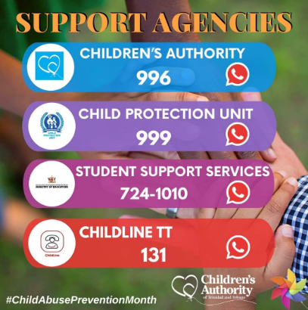  - MOE STUDENT SUPPORT SERVICES DIVISION - Hotline Service  file:///C:/Users/MOE_Student/Downloads/Hotline%20Service%20School%20Social%20Workers.pdf | - Audible Stories – Audible.com  https://stories.audible.com/start-listen  - E-books and novels  https://drive.google.com/drive/u/0/folders/1z9t1AipbmTa2T522B_8Ymm1o8TK5UkHC  - free audio books from amazon in 6 language  https://stories.audible.com/discovery  - Free virtual Visits to 17 European museums.  https://www.demotivateur.fr/article/visiter-des-musees-sans-bouger-de-son-canape-le-plan-parfait-pendant-la-quarantaine-19057  - 700 Free books from Cambridge press  https://www.demotivateur.fr/article/visiter-des-musees-sans-bouger-de-son-canape-le-plan-parfait-pendant-la-quarantaine-19057  - Free broadway shows  https://www.insider.com/stream-broadway-musicals-plays-for-free-online-limited-time-coronavirus-2020-3  - Reader: Download the World Book eBooks app on your devices – over 3000 ebooks and audiobooks  https://worldbook.kitaboo.com/reader/worldbook/index.html#!/  - Online fun activities, games and learning resources for children at home  https://www.turtlediary.com/

